Press Release

FEV expands Alsdorf location to include modern testing center with climatic emissions rollers
Aachen, May 2018 – On May 28, a groundbreaking ceremony for FEV’s new testing center in Alsdorf took place. The state-of-the-art facility will be next to the existing FEV buildings on Konrad-Zuse-Straße and will allow emissions and range tests to be performed to meet the latest worldwide legal standards.

“Further reduction of emissions and consumption is becoming increasingly important for our customers in light of current social discussions and regulation of future consumption targets. This investment at the Alsdorf location takes into account the development of clean and highly efficient drive systems,” explains Professor Stefan Pischinger, President and CEO of the FEV Group.

At the same time, the construction project shows a clear commitment to the Aachen region where the company has had its roots since being founded 40 years ago.

Forward-Looking Test Conditions
The new building will have a four-wheeled chassis dynamometer with state-of-the-art emissions technology for performing emissions tests in accordance with the latest legislation from the US, Europe, China, Japan, and India. In addition to the measuring and testing equipment required to optimize conventional powertrains, the testing center is designed for developing hybrid and electric vehicles. The vehicle conditioning area is approximately 1,700 square meters (around 18,300 square feet) and is divided into three different temperature ranges for conditioning, from -30°C to 50°C (-22°F to 122°F). The overall building layout is optimized for roller and PEMS test operations and will also allow an additional test bench and solar simulation system to be added in the future.

In addition, the expansion will involve doubling the Parc Fermé for test vehicles by an additional 200 spaces. There will also be charging stations for battery electric vehicles (BEV) and off-vehicle charging, hybrid electric vehicles (OVC-HEV).
About FEV
The FEV Group, with headquarters in Aachen, Germany, is an internationally renowned service provider in the area of vehicle development. The skill spectrum of FEV includes consulting and the development and testing of innovative vehicle concepts, all the way up to serial production. In addition to engine and transmission development, vehicle integration, and the calibration and homologation of modern vehicle powertrains, the development of hybrid and electric drive systems as well as alternative fuels is constantly increasing in importance. Another area of activity includes optimizing electronic control systems as well as the increasing connectedness of cars. In this context, one particular focus is the continued development of autonomous vehicles.

The FEV Software and Testing Solutions product portfolio complements this offering by producing cutting-edge test bench measuring equipment in addition to software solutions that help make development more efficient and transfer significant process steps from the road to the test rig – or even to a computer simulator.

As a globally operating service provider, the company offers these services to its customers from the transport sector worldwide. The FEV Group employs over 5,000 highly qualified specialists in modern development centers close to our customers at more than 40 locations on four continents.

Images
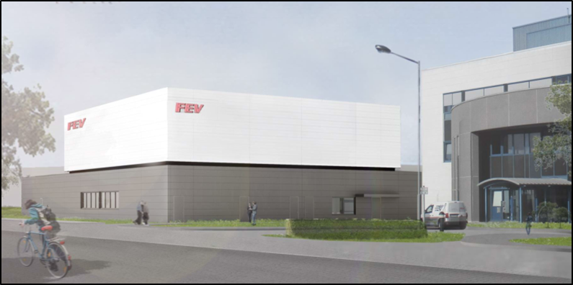
[Caption: The future FEV roller testing center offers state-of-the-art trial possibilities for sustainable drive systems (computer model)] / Source: FEV Group

Contact
Marius Strasdat
Tel.: +49 241 5689-6452
E-mail: strasdat@fev.com

