Press Release

FEV North America receives Toyota Supplier Award for the second consecutive year

Auburn Hills (Michigan, USA) / Aachen, July 2019 – Engineering services provider FEV North America, Inc. (FEV) was recently presented with the 2019 Supplier Award for Superior Performance for work conducted with Toyota Motor North America, Inc. (TMNA) throughout 2018. For the second consecutive year, FEV was recognized for its technical expertise and reliable quality as well as the high level of customer service it provides.

“We are thrilled to once again be recognized for our expertise and technical capabilities by our long-term partner, Toyota,” said Patrick Hupperich, President and CEO of FEV North America Inc. “It’s not only a tremendous honor to have TMNA recognize our work, but it shows that FEV’s corporate values aren’t just words. This is an excellent showcase of our ‘Customer Focus’ value which states the customer is supreme and we strive to deliver value beyond their expectations.”

FEV collaborates with TMNA’s engineering design groups to provide cost and engineering solutions through value engineering, vehicle benchmark analysis and data-collection activities. The company’s benchmarking expertise has resulted in enhanced virtual model development, as well as efficiencies in future powertrain design decisions.

TMNA annually evaluates supplier performance across engineering and purchasing with pre-established criteria for quality, customer service, management, and cost improvement. Superior performance awardees received the highest scores from these evaluations.

“FEV is an important partner to Toyota’s North American R&D operations through powertrain and driveline benchmarking,” said Greg Laskey, Vice President, Purchasing at Toyota Motor North America, Inc. “We appreciate their strong focus on continuous improvement and design cost optimization, and look forward to continued collaboration as we develop future products for an ever-changing market.”

About FEV
The FEV Group, with its headquarters in Aachen, Germany, is an internationally renowned service provider in the area of vehicle development. The skill spectrum of FEV includes consulting and the development and testing of innovative vehicle concepts, all the way up to serial production. In addition to engine and transmission development, vehicle integration, and the calibration and homologation of modern vehicle powertrains, the development of hybrid and electric drive systems as well as alternative fuels is constantly increasing in importance. Another area of activity includes optimizing electronic control systems as well as the increasing connectedness of cars. In this context, one particular focus is the continued development of autonomous vehicles.

The FEV Software and Testing Solutions product portfolio complements this offering by producing cutting-edge test bench measuring equipment in addition to software solutions that help to make the development process more efficient and transfer significant process steps from the road to the test rig – or even to a computer simulator.

As a globally operating service provider, the company offers these services to its customers from the transport sector worldwide. The FEV Group employs over 6,300 highly qualified specialists in modern development centers close to our customers at more than 40 locations on four continents.

About Toyota
Toyota (NYSE:TM) has been a part of the cultural fabric in the U.S. and North America for more than 60 years, and is committed to advancing sustainable, next-generation mobility through our Toyota and Lexus brands. During that time, Toyota has created a tremendous value chain as our teams have contributed to world-class design, engineering, and assembly of more than 38 million cars and trucks in North America, where we have 14 manufacturing plants, 15 including our joint venture in Alabama (10 in the U.S.), and directly employ more than 47,000 people (over 36,000 in the U.S.). Our 1,800 North American dealerships (nearly 1,500 in the U.S.) sold 2.8 million cars and trucks (2.4 million in the U.S.) in 2018.
Through the Start Your Impossible campaign, Toyota highlights the way it partners with community, civic, academic and governmental organizations to address our society's most pressing mobility challenges. We believe that when people are free to move, anything is possible. For more information about Toyota, visit www.toyotanewsroom.com.

Image

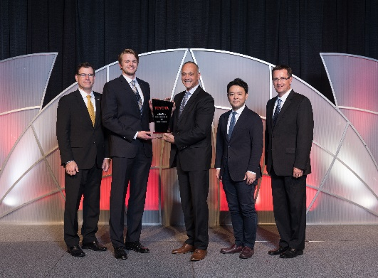
FEV North America receives Toyota Supplier Award for the second consecutive year
Source: FEV Group

Contact
Samantha Simmerson
Tel.: 248.725.7578
E-mail: Simmerson@fev.com

