Press Release

FEV acquires 100% of shares in B&W Fahrzeugentwicklung
Aachen, June 2018 – On May 16, 2018, globally active engineering service provider FEV signed a purchase contract for the acquisition of B&W Fahrzeugentwicklung GmbH which still requires the approval of the relevant authorities. With this strategic step, FEV is expanding its expertise and capacities in the Global Vehicle Development business segment. With more than 300 employees at international locations, B&W offers its customers solutions in the fields of body shells, interior, exterior, surfacing, model construction, testing, and electricity/electronics. With the fully owned B&W subsidiary EDL Rethschulte GmbH, expertise in the field of lighting technology is also expanding.

"Need-appropriate mobility solutions will change the transportation industry in the long term and set new requirements for future vehicle concepts, for instance with regard to the exterior and interior," explains Professor Stefan Pischinger, President and CEO of the FEV Group. "With the integration of B&W into the FEV Group, we are expanding our capacities and are also gaining important employees with engineering expertise in these critical aspects of vehicle development."

"With our expertise in the fields of body shells, lighting technology, exterior, interior, and surfacing, we are convinced that B&W will become a significant part of the FEV Group," adds Haraldo Brandenburg, Managing Director of B&W Fahrzeugentwicklung GmbH. "From the development of individual modules to entire bodies, we can provide our global automotive customers with everything from a single source."
B&W Fahrzeugentwicklung GmbH was founded in 1998 and has recorded continuous growth ever since. Sven Vseticek, Managing Director of B&W Fahrzeugentwicklung GmbH, states, “In times of increasingly complex project assignments, which focus on integrated vehicle competence, the decision underpins the claim to be a reliable partner in the overall vehicle development and to grow customer-oriented. Together, we offer a comprehensive portfolio that enables us to provide ideal solutions to our customers' needs.” With its innovative services and own products, B&W is already a force to be reckoned within the European automotive industry.
About FEV
The FEV Group, with its headquarters in Aachen, Germany, is an internationally renowned service provider in the area of vehicle development. The skill spectrum of FEV includes consulting and the development and testing of innovative vehicle concepts, all the way up to serial production. In addition to engine and transmission development, vehicle integration, and the calibration and homologation of modern vehicle powertrains, the development of hybrid and electric drive systems as well as alternative fuels is constantly increasing in importance. Another area of activity includes optimizing electronic control systems as well as the increasing connectedness of cars. In this context, one particular focus is the continued development of autonomous vehicles.

The FEV Software and Testing Solutions product portfolio complements this offering by producing cutting-edge test bench measuring equipment in addition to software solutions that help make development more efficient and transfer significant process steps from the road to the test rig – or even to a computer simulator.

As a globally operating service provider, the company offers these services to its customers from the transport sector worldwide. The FEV Group employs over 5,300 highly qualified specialists in modern development centers close to our customers at more than 40 locations on four continents.

Image
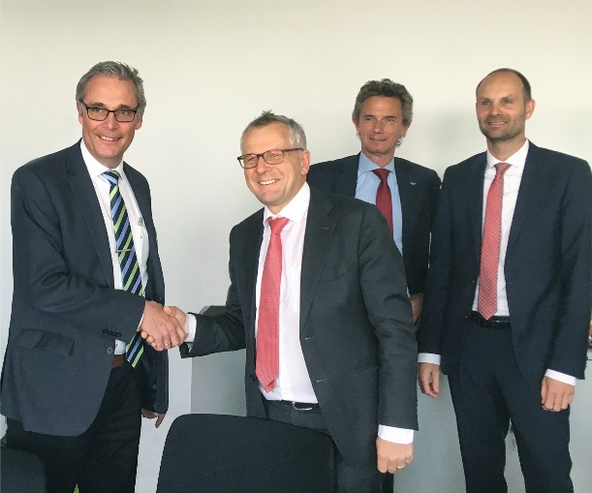
[From left to right: Haraldo Brandenburg, Managing Director of B&W Fahrzeugentwicklung GmbH; Professor Stefan Pischinger, President and CEO of the FEV Group; Dr. Norbert Alt, Chairman of the Executive Board of FEV Europe GmbH; Jürgen Koopsingraven, CFO of FEV Group]
Source: FEV Group
Contact
Marius Strasdat
Tel.: +49 241 5689-6452
E-mail: strasdat@fev.com

