Press Release

Collaborative “Closed Carbon Cycle Mobility” project develops climate-neutral fuels for the mobility of tomorrow
.
Aachen, March 2019 – In the past year, the collaborative project coordinated by FEV Europe GmbH, named “Closed Carbon Cycle Mobility – Climate-neutral fuels for the transportation of the future” (C³ Mobility), was launched. The project is part of the the German Federal Ministry for Economy and Energy’s “Energy revolution in transportation: Sector coupling through the use of power-based fuels” initiative. Its goal for the next three years is to determine new paths toward the CO₂-neutral mobility of the future. To this end, 30 partners have joined forces in a cross-industry consortium from the areas of energy supply, processing technology, automotive and utility vehicle engine manufacturers, as well as research and development.
In energy and climate research, the goal is to develop system solutions together with all the relevant players. Thus, power, mobility, and heat cannot be considered separately, but must be jointly optimized through sector coupling. This is the only way that coordination and cost-efficient development of various infrastructures is possible, which is necessary in order to meet the requirements of the future fluctuating energy sources (sun and wind).

To this end, fluid energy carriers are a very effective means for transporting and storing large quantities of energy. Of particular importance is the use of regeneratively generated fuel based on methanol. In addition to direct use as fuel, C³ Mobility also intends to study further processing into other forms of fuel. Ways of reducing CO₂ fleet emissions, as achieved today through the inclusion of power-based fuels, should also be shown. To this end, synthetic gasoline (through a methanol-to-gasoline process) will be produced in a demonstration facility and its use in a gasoline engine shown. In addition, also based on methanol, other fuels for diesel engine applications will be examined and assessed.

The C³ Mobility consortium will determine the vehicle suitability of the new fuels under real driving conditions. In doing so, a comprehensive assessment will be made regarding its effectiveness and eco-friendliness in the manufacturing and consumption chains, as well as in sales and market launch.
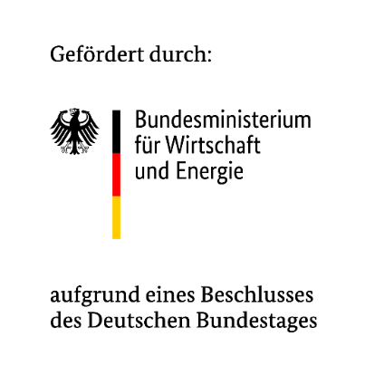
This research project is sponsored by the German Federal Ministry for Economy and Energy. Responsibility for the content of this publication lies with the author.

About FEV
The FEV Group, with its headquarters in Aachen, Germany, is an internationally renowned service provider in the area of vehicle development. The skill spectrum of FEV includes consulting and the development and testing of innovative vehicle concepts, all the way up to serial production. In addition to engine and transmission development, vehicle integration, and the calibration and homologation of modern vehicle powertrains, the development of hybrid and electric drive systems as well as alternative fuels is constantly increasing in importance. Another area of activity includes optimizing electronic control systems as well as the increasing connectedness of cars. In this context, one particular focus is the continued development of autonomous vehicles.

The FEV Software and Testing Solutions product portfolio complements this offering by producing cutting-edge test bench measuring equipment in addition to software solutions that help to make the development process more efficient and transfer significant process steps from the road to the test rig – or even to a computer simulator.

As a globally operating service provider, the company offers these services to its customers from the transport sector worldwide. The FEV Group employs over 5,900 highly qualified specialists in modern development centers close to our customers at more than 40 locations on four continents.

Images
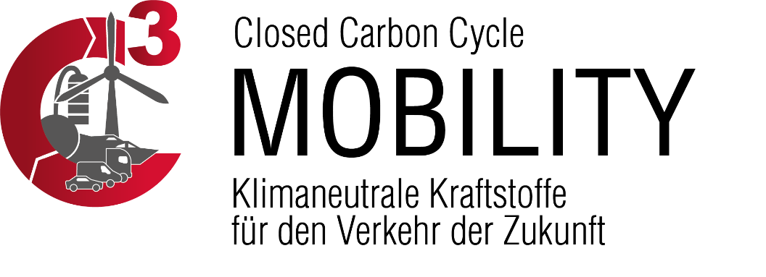
Source: FEV

Contact
Marius Strasdat
Tel.: +49 241 5689-6452
E-mail: strasdat@fev.com

