Press Release

FEV and Coventry University Launch Centre for Clean Mobility Development

Coventry/Aachen, March 21, 2019 – The Centre for Advanced Low-Carbon Propulsion Systems (C-ALPS), a state-of-the-art facility for creating clean mobility solutions, has opened in Coventry (UK) today. C-ALPS, an innovative collaboration between global engineering specialist, FEV Group, and Coventry University, is looking to harness cutting-edge academic and commercial expertise to support the development of the next generation of electric, hybrid and combustion engines.

More than 30,000 sq ft of development space at the Technology Park of Coventry, near to the National Transport Design Center, will house some of the most advanced internal combustion and electrification test bed facilities currently available in the UK, creating a dedicated resource for testing current and future powertrain solutions quickly and efficiently. The capabilities will be available to OEMs, SMEs in the supply chain, and technology partners keen to accelerate the creation of new propulsion systems for use across automotive, aerospace, marine and rail sectors.

"We are convinced that Coventry University is the ideal partner for the development of powertrain solutions in the UK due to its research focus and the conditions prevailing here. In addition, it is important for us to be on-site with our customers. With C-ALPS, we can ensure this, and develop modern and clean powertrain solutions for our customers in the UK with the most advanced capabilities", said Professor Stefan Pischinger, President & CEO of FEV Group.

“This collaboration is very encouraging news and a welcome boost for the UK automotive industry,” explained Professor Richard Dashwood, Deputy Vice-Chancellor at Coventry University. “We have a real opportunity for the country to lead the rest of the world when it comes to developing low carbon propulsion systems and C-ALPS has a major role to play in making this happen. It’s all about bringing the best of both worlds together, using the expertise and track record of FEV Group in engineering consultancy and combining it with the academic knowledge of our professors to create a real centre of excellence. Automotive is naturally the first target, but the technology will also be available to support the evolution of other sectors.”

Operating within Coventry University’s Future Transport & Cities Research Institute, C-ALPS has been designed and built to be the most advanced test facility of its type in the UK.
FEV's development test benches meet all the conditions with which current and future engines are confronted. It also houses test benches for powertrain components, including turbochargers, catalytic converters, battery systems and electric machines.

Three world class professors have also been recruited to lead the research team and they bring with them significant experience and knowledge in battery storage, power electronics and electric machines.

More than 100 people from the industry, science and politics attended today's official opening of C-ALPS. In addition to speeches by representatives of FEV and Coventry University, Richard Harrington, Minister for Business and Industry, addressed the audience and praised C-ALPS's commitment to research and development. This was followed by a tour of the modern facility.

About Coventry University
Coventry University is a dynamic, global and transformational modern university, ranked No.13 UK University (Guardian University Guide 2019). Transport has been a key part of the university and the City of Coventry for over 150 years and the university has a strong tradition in transport design, manufacturing and the automotive business environment. Future Transport & Cities is a multidisciplinary research institute that is internationally recognised for its ability to engage with industry and develop innovative technology that can be commercially applied.

About FEV
The FEV Group, with its headquarters in Aachen, Germany, is an internationally renowned service provider in the area of vehicle development. The skill spectrum of FEV includes consulting and the development and testing of innovative vehicle concepts, all the way up to serial production. In addition to engine and transmission development, vehicle integration, and the calibration and homologation of modern vehicle powertrains, the development of hybrid and electric drive systems as well as alternative fuels is constantly increasing in importance. Another area of activity includes optimizing electronic control systems as well as the increasing connectedness of cars. In this context, one particular focus is the continued development of autonomous vehicles.

The FEV Software and Testing Solutions product portfolio complements this offering by producing cutting-edge test bench measuring equipment in addition to software solutions that help to make the development process more efficient and transfer significant process steps from the road to the test rig – or even to a computer simulator.

As a globally operating service provider, the company offers these services to its customers from the transport sector worldwide. The FEV Group employs over 6,000 highly qualified specialists in modern development centers close to our customers at more than 40 locations on four continents.

Image

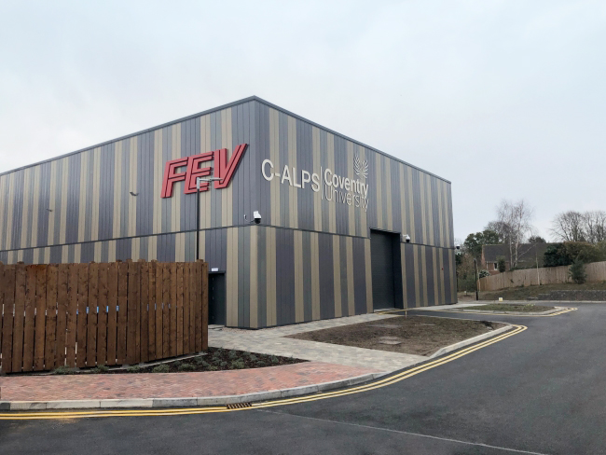
[FEV and Coventry University launch C-ALPS, a centre for cleaner mobility; source: FEV]

Contact
Marius Strasdat
Tel.: +49 241 5689-6452
E-mail: strasdat@fev.com

