Press Release

Efficient Data Management for Autonomous Driving: FEV accelerates development time with Microsoft Azure

Frankfurt/Aachen, September 2019 – Automated driving functions and autonomous driving fundamentally influence the way we will move in future. Validating these functions require systems that recognize the various scenarios in road traffic during test drives, evaluate them, and prepare them for the developers. The global vehicle developer, FEV, is overcoming this central challenge with a data management and assessment system developed in-house, which uses the computing power of Microsoft’s cloud platform Azure. The system will be presented at the International Motor Show (IAA) from 10 to 15 September 2019 in Hall 5.0, booth C21.

By today's estimates, test scopes of 240 million to 16 billion kilometers of road* are needed to validate an automated driving function. However, it is not the quantity of tests that determines the maturity of a system, but the number of road traffic situations “experienced” in which the algorithms have to actively make a decision – for example, during an overtaking maneuver on the highway.

In this regard, the V2I (Vehicle-to-Infrastructure) data management system established by FEV is an efficient solution for the development and validation of such driving functions. This is because aside from the duration and number of test drives, the quantities of data obtained are also a major challenge with regard to the validation. The sensor set installed in the vehicle, consisting of cameras, lidar (light detection and ranging), and radar (radio detection and ranging), quickly generates up to 40 terabytes of data in a single day.

That is precisely what the data management solution from FEV deals with. First, a networked data logger developed in-house takes over the collection of selected vehicle signals and sends them to a back-end in real time during the test drive. With Microsoft Azure and Azure IoT Hub transferring the data, FEV was able to build on an established, high-performance, highly secure cloud platform. The sent vehicle data is consolidated in the cloud, while algorithms analyze these signals in regards to relevant scenarios. It is therefore possible to send feedback to the relevant engineers even during test drives, and to flexibly coordinate entire fleets according to a predefined plan.

A standardized time stamp also significantly simplifies the cleaning and preparation of all vehicle data. Not least, this scenario-based pre-filtering also enables cost-efficient data storage in the cloud. Only previously-detected data packets or scenarios are loaded into the cloud hot storage, which is the layer with the highest available computing power and access management. Less important sections are saved in lower performance cloud areas that are consequently more affordable.

As an integration and development partner in series production projects of various automotive manufacturers, the efficient assessment and validation of sensor data quickly proved its worth for FEV and its clients. To minimize the general testing time on real streets and the associated costs, the development service provider is increasingly transferring significant test scopes to simulation and laboratory environments. According to Professor Stefan Pischinger, President & CEO of the FEV Group, these plans are moving ahead: “The data-logger solution, in combination with FEV’s own cloud-based labeling software, is a significant milestone for the construction of a holistic development environment for ADAS/AD environments. The efficient preparation of the data using automated recognition and classification according to driving situation is the basis for all other process steps in this regard."

While the driver assistance systems in series production today are still based on predefined rules, in the future, FEV believes that this will also be possible with the use of machine learning. “Our goal will only have been reached when artificial intelligence can handle even the most complex of situations and accurately anticipate the behavior of road users,” says Professor Pischinger.

The collaboration with Microsoft is an important component of this. Interdisciplinary collaboration between sections of the automotive industry and IT is enabling groundbreaking, cross-company innovations to be established, which offer significant advantages in the development process.

*Sources:
How many Miles of driving would it take to demonstrate Autonomous Vehicle Reliability? Nidhi Kalra, Susan Paddock

Prof. Hermann Winner, Head of Vehicle Technology, Project Leader Pegasus
About FEV
The FEV Group, with its headquarters in Aachen, Germany, is an internationally renowned service provider in the area of vehicle development. The skill spectrum of FEV includes consulting and the development and testing of innovative vehicle concepts, all the way up to serial production. In addition to engine and transmission development, vehicle integration, and the calibration and homologation of modern vehicle powertrains, the development of hybrid and electric drive systems as well as alternative fuels is constantly increasing in importance. Another area of activity includes optimizing electronic control systems as well as the increasing connectedness of cars. In this context, one particular focus is the continued development of autonomous vehicles.

The FEV Software and Testing Solutions product portfolio complements this offering by producing cutting-edge test bench measuring equipment in addition to software solutions that help to make the development process more efficient and transfer significant process steps from the road to the test rig – or even to a computer simulator.
As a globally operating service provider, the company offers these services to its customers from the transport sector worldwide. The FEV Group employs over 6,400 highly qualified specialists in modern development centers close to our customers at more than 40 locations on five continents.

Images:
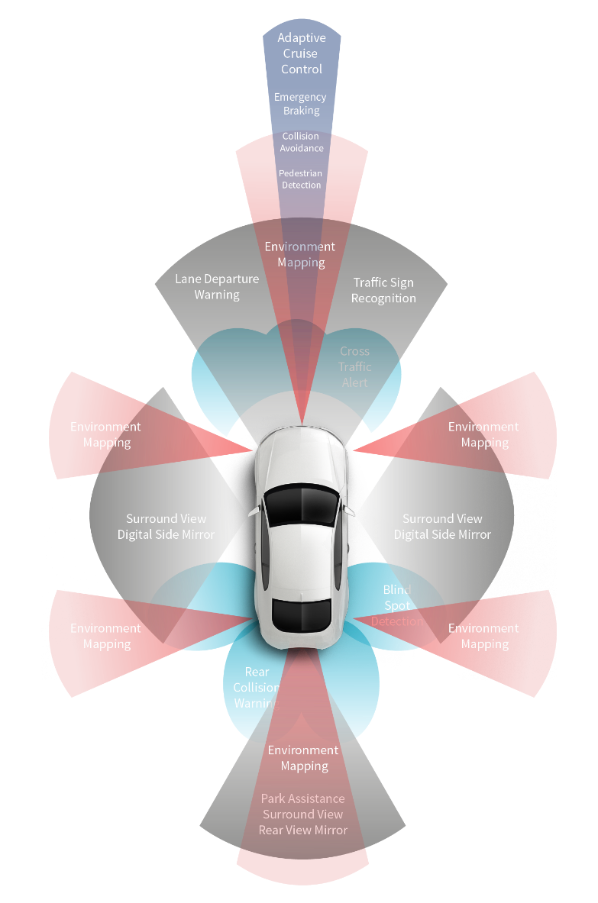

The validation of automated driving functions generates large amounts of data (source: FEV)
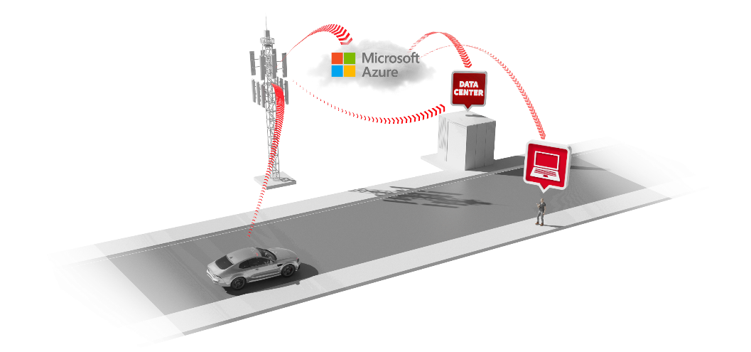

FEV’s efficient data management for autonomous driving (source: FEV)

Contact
Marius Strasdat
Tel.: +49 241 5689-6452
E-Mail: strasdat@fev.com

