Press Release

Stefan Kreysa to Become CFO of FEV Europe GmbH
Aachen, June 2018 – Effective June 1, Stefan Kreysa will take over the CFO and Executive Vice President role within FEV Europe GmbH. In this role, he will further develop the efficiency optimization and customer orientation of the internationally active engineering service provider in Europe. He succeeds Jürgen Koopsingraven, who was appointed CFO within the FEV Group.
"With Stefan Kreysa, FEV is gaining an experienced manager who has been working in the automotive supplier industry for more than 20 years and, in various capacities, has been responsible for strategic development, among other things," says Professor Stefan Pischinger, President & CEO of the FEV Group.
Prior to joining FEV Europe, Mr. Kreysa was CFO of an automotive security system manufacturer in Southern Germany for many years. Most recently, he served as Vice President of Finance for a globally positioned automotive and aviation supplier group for the Europe region.

About FEV
The FEV Group, with its headquarters in Aachen, Germany, is an internationally renowned service provider in the area of vehicle development. The skill spectrum of FEV includes consulting and the development and testing of innovative vehicle concepts, all the way up to serial production. In addition to engine and transmission development, vehicle integration, and the calibration and homologation of modern vehicle powertrains, the development of hybrid and electric drive systems as well as alternative fuels is constantly increasing in importance. Another area of activity includes optimizing electronic control systems as well as the increasing connectedness of cars. In this context, one particular focus is the continued development of autonomous vehicles.

The FEV Software and Testing Solutions product portfolio complements this offering by producing cutting-edge test bench measuring equipment in addition to software solutions that help make development more efficient and transfer significant process steps from the road to the test rig – or even to a computer simulator.

As a globally operating service provider, the company offers these services to its customers from the transport sector worldwide. The FEV Group employs over 5,300 highly qualified specialists in modern development centers close to our customers at more than 40 locations on four continents.

Images
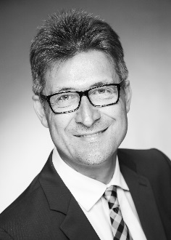
[Image: Stefan Kreysa takes over as CFO and Executive Vice President within FEV Europe GmbH]
Source: FEV Group

Contact
Marius Strasdat
Tel.: +49 241 5689-6452
E-mail: strasdat@fev.com

