Press Release

“Zero CO₂ Mobility” –
International conference presents solutions for carbon dioxide-neutral mobility

Aachen, October 2019 – The “climate package” recently presented by the German government shows how additional measures are necessary in reducing pollutant emissions and stopping climate change. For some, the decision does not go far enough. The transport sector and its carbon dioxide emissions are a frequent topic of discussion. At the “Zero CO₂ Mobility” conference, the development service provider, FEV, will discuss and present solutions for this key area together with top-class experts. The event will take place from November 7-8, 2019 in Aachen.

“Particularly in the case of mobility, targeted ways of reducing CO₂ emissions must be offered. Pure battery electric drives are said to have a high potential – for the planned emission reductions, however, they are not sufficient to be the only seriously pursued measure to achieve CO₂-neutral mobility”, says Professor Stefan Pischinger, President & CEO of the FEV Group and patron of the conference.

This is due to the short range on the one hand, which makes them unattractive especially for freight transport, but also to infrastructural aspects such as a lack of charging stations. In addition, most of the electricity currently available in Germany is still generated in coal-fired power plants.

Newly developed, partly multi-speed electric drive components considerably increase the performance of modern battery electric vehicles and extend their range. But, regenerative fuels, also known as “e-fuels”, offer considerable potential. They can already significantly reduce CO₂ emissions in the near future, as they have a much greater leverage effect over existing fleets than e-vehicles, whose market share is still small. Fuel cell technology is also a promising and powerful alternative that should be considered.

The “Zero CO₂ Mobility” provides experts and decision-makers with the opportunity for an interdisciplinary exchange in which participants receive answers to the questions under which conditions individual approaches make sense and which competences must be bundled in order to significantly reduce emission values. Among the top-class speakers this year will be Dr. Georg Bäuml, Head of Environmental Affairs at Volkswagen, Randy MacEwen, CEO at Ballard and Professor Reinhold Elsen, Head of R&D at RWE Power.

Further information and registration at: www.fev.com/zero-co2-mobility
About FEV
The FEV Group, with its headquarters in Aachen, Germany, is an internationally renowned service provider in the area of vehicle development. The skill spectrum of FEV includes consulting and the development and testing of innovative vehicle concepts, all the way up to serial production. In addition to engine and transmission development, vehicle integration, and the calibration and homologation of modern vehicle powertrains, the development of hybrid and electric drive systems as well as alternative fuels is constantly increasing in importance. Another area of activity includes optimizing electronic control systems as well as the increasing connectedness of cars. In this context, one particular focus is the continued development of autonomous vehicles.

The FEV Software and Testing Solutions product portfolio complements this offering by producing cutting-edge test bench measuring equipment in addition to software solutions that help to make the development process more efficient and transfer significant process steps from the road to the test rig – or even to a computer simulator.

As a globally operating service provider, the company offers these services to its customers from the transport sector worldwide. The FEV Group employs over 6,500 highly qualified specialists in modern development centers close to our customers at more than 40 locations on five continents.

Image

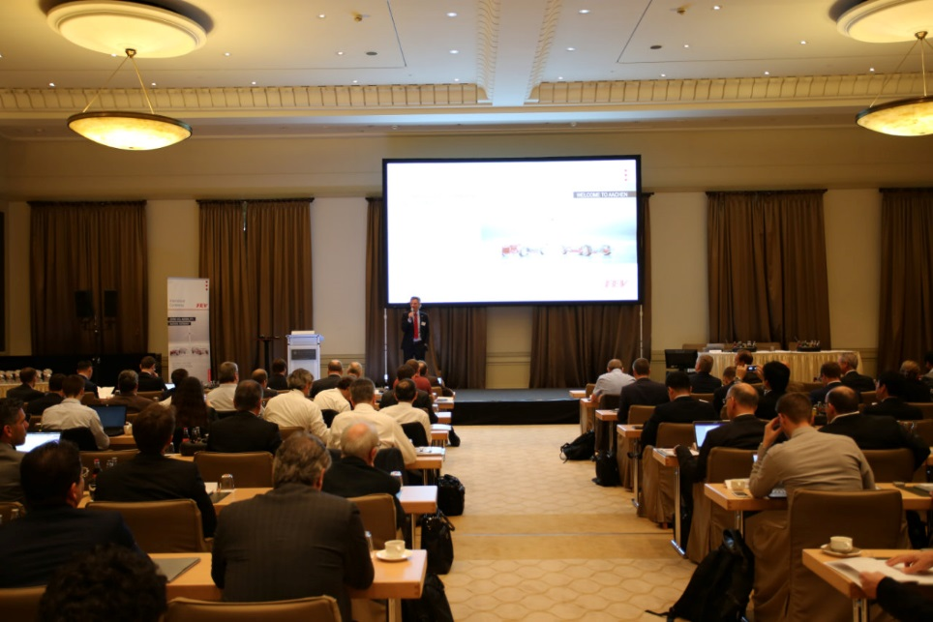
Last year, more than 150 experts and decision-makers from various disciplines exchanged ideas at the “Zero CO2 Mobility” conference in Aachen; Source: FEV Group

Contact
Marius Strasdat
Phone: +49 241 5689-6452
E-mail: strasdat@fev.com

