Press Release

Dr. Ulrich Pfahl appointed Chairman of the Executive Board of FEV Asia GmbH

Aachen, December 2019 – Effective January 1, 2020, Dr. Ulrich Pfahl will become Chairman of the Executive Board of FEV Asia GmbH. In this position, he will be responsible for the business activities of the FEV subsidiaries in Asia. Dr. Pfahl succeeds Dr. Ernst Scheid, who has reached retirement age after 35 years with the company but will continue to serve the FEV Group in an advisory capacity.

Dr. Pfahl has held various positions in the FEV Group since 2016, most recently assuming market responsibility for China and Japan. He studied aerospace engineering at the RWTH Aachen University, where he subsequently earned his doctorate in the Faculty of Mechanical Engineering. Dr. Pfahl has extensive technical knowledge and experience in building and managing local organizations, including those in Asia, through various positions with automotive manufacturers, suppliers and consulting companies.

"We are delighted to fill the position of chairman for FEV Asia optimally with Dr. Pfahl. At the same time, we would like to thank Dr. Scheid for his long-standing cooperation and tremendous contributions to our company", said Professor Stefan Pischinger, Chairman of the Executive Board and Managing Partner of FEV Group GmbH.

About FEV
The FEV Group, with its headquarters in Aachen, Germany, is an internationally renowned service provider in the area of vehicle development. The skill spectrum of FEV includes consulting and the development and testing of innovative vehicle concepts, all the way up to serial production. In addition to engine and transmission development, vehicle integration, and the calibration and homologation of modern vehicle powertrains, the development of hybrid and electric drive systems as well as alternative fuels is constantly increasing in importance. Another area of activity includes optimizing electronic control systems as well as the increasing connectedness of cars. In this context, one particular focus is the continued development of autonomous vehicles.

The FEV Software and Testing Solutions product portfolio complements this offering by producing cutting-edge test bench measuring equipment in addition to software solutions that help to make the development process more efficient and transfer significant process steps from the road to the test rig – or even to a computer simulator.

As a globally operating service provider, the company offers these services to its customers from the transport sector worldwide. The FEV Group employs over 6,600 highly qualified specialists in modern development centers close to our customers at more than 40 locations on five continents.

Image
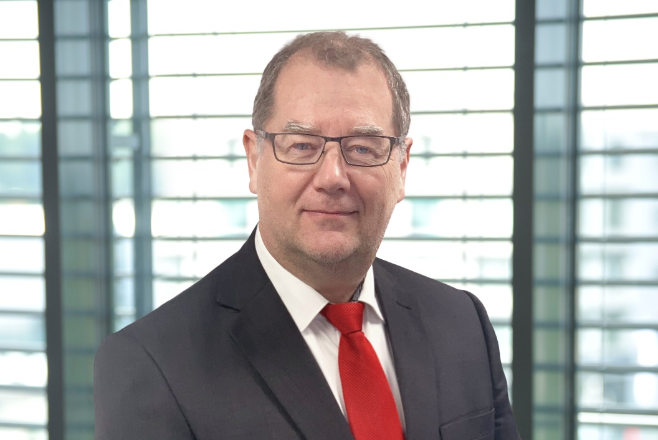
[Dr. Ulrich Pfahl appointed to Chairman of the Executive Board of FEV Asia GmbH] – Source: FEV Group
Contact
Marius Strasdat
Tel.: +49 241 5689-6452
E-Mail: strasdat@fev.com

