Press Release

FEV expands business in Asia with the foundation of FEV Thailand Co., Ltd.
Bangkok, August 2018 – On August 8 in Bangkok, an inauguration ceremony for FEV’s Thailand subsidiary took place and included Government officials and customers. With this new location, FEV continues its growth in Asia with a goal of supporting the regional mobility sector in the development of vehicles and engines, transmissions and electric powertrains, including batteries and fuel cells.

FEV Thailand is located South-east of Bangkok in Sriracha, Chon Buri. “Thailand’s automotive sector is growing fast and needs technology for future mobility. Clean air, sustainable energy supply and highly efficient drive systems are needed worldwide, and FEV helps to develop technical solutions for the future targets”, states Prof. Stefan Pischinger, President and CEO of FEV Group.

“Mega cities, like Bangkok, can improve air quality and safety significantly by implementing solutions from FEV for conventional vehicles and e-vehicles, including 2- and 3-wheelers. To be efficient in product development, it is important to be close to the customer and to use the global FEV knowledge efficiently”, said Dr. Ernst Scheid, CEO of FEV Asia.

FEV has already conducted projects in the region, including improving conventional powertrains for South-east Asia, delivering test equipment for product development and end-of-line quality control, and providing hardware and software for the Thai Industry 4.0.

Dr. Andreas Pungs has been assigned as Managing Director of FEV Thailand Co., Ltd. He joined the FEV Group 20 years ago and is well-versed in the Asian market. Previously, Pungs served as CTO of FEV China where he was responsible for product development and prior to that, he worked in FEV’s powertrain lab in India.

About FEV
The FEV Group with headquarters in Aachen, Germany, is an internationally renowned service provider in the area of vehicle and mobility solutions. The skill spectrum of FEV includes consulting and the development of innovative vehicles and powertrains up to serial production. In addition to complete car body development, engine and transmission development, vehicle integration, and the calibration and homologation of modern vehicle powertrains, the development of hybrid and electric drive systems as well as alternative fuels is constantly increasing in importance. Another area of activity includes optimizing electronic control systems as well as the increasing connectedness of cars. In this context, one particular focus is the continued development of autonomous driving.

The FEV Software and Testing Solutions product portfolio complements this offering by producing cutting-edge test bench measuring equipment in addition to software solutions that help make development more efficient and transfer significant process steps from the road to the test rig – or even to a computer simulator.

The FEV Group employs about 5,600 highly qualified specialists in modern development centers close to our customers at more than 40 locations on four continents.

Image
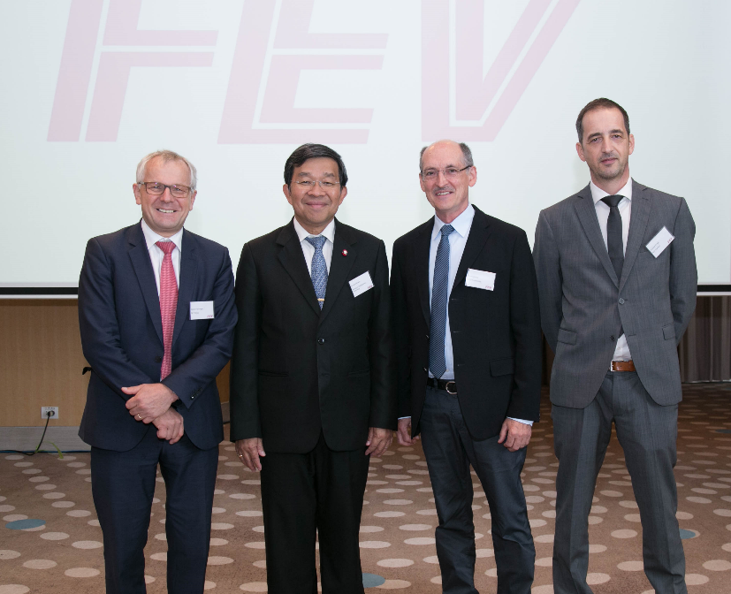
FEV expands its Asia business with the foundation of FEV Thailand Co., Ltd.
[From left to right: Professor Stefan Pischinger, President & CEO of FEV Group; Dr. Soranit Siltharm, Permanent Secretary, Ministry of Science and Technology, Thailand; Dr. Ernst Scheid, Executive Vice President of FEV Europe GmbH and Chairman of the Executive Board of FEV Asia GmbH ; Dr. Andreas Pungs, Managing Director of FEV Thailand Co., Ltd.]

Contact
FEV Thailand Co., Ltd.
Dr. Andreas Pungs
12th Floor Harbor Mall, 4/222 Moo 10
Sukhumvit Road, Thungsukha
Sriracha, Chonburi, 20230
Thailand
Phone +66 (0)33 030 770
fev-thailand@fev.com

