FOR IMMEDIATE RELEASE
October 30, 2018
FEV Designated as Strategic Integrator for
PolySync’s DriveKit System

Partnership provides DriveKit customers advanced autonomous driving technology development, installation and testing services

Auburn Hills, MI – FEV North America, Inc. (FEV), a global leader providing advanced mobility solutions for the transportation industry, has entered into a partnership with PolySync Technologies, a leading developer of solutions for advanced testing and development of driverless vehicle technology. The partnership designates FEV as a strategic integrator of PolySync’s DriveKit, a comprehensive system allowing for full control of steering, braking, throttle, and gear selection for advanced testing and development of self-driving vehicles.

“This partnership is beneficial to all involved – FEV, PolySync and DriveKit customers – and we are excited and honored to be a part of it,” said Tom Tasky, Director of Intelligent Mobility and Software at FEV North America, Inc. “Many companies are working on technologies for autonomous driving and with FEV’s focus on future mobility solutions, including self-driving applications, DriveKit supports our ability to provide a dynamic and valuable solution for our customers working on these advanced technologies.”

FEV utilizes its system expertise, in-house equipment and vehicle lab to install the DriveKit, sensors, and computer hardware on customer vehicles to support autonomous fleet development. Beyond installation, FEV’s services include hardware integration, sensor fusion, localization, and motion planning; functional safety; cyber security; data processing and V2X communications; custom automated test systems; simulation; and performance benchmarking from a full autonomous system or at the component level.

“As demand for autonomous vehicle technology grows, OEMs are seeking solutions that can help them meet this need. The superior safety and speed of implementation into the vehicle platform that DriveKit enables will help FEV’s customers optimize their development cycles with predictable results in the shortest amount of time possible,” said PolySync Technologies CEO, Greg Drew. “We have a deep respect for our partners like the FEV Group and we look forward to working together to advance the state of autonomous mobility.”

PolySync’s DriveKit interfaces directly with the vehicle communication network so there is no need to interact directly with the vehicle systems. The test driver can easily regain control of the vehicle at any time by overriding through the steering, braking, throttle, or E-stop. All vehicle control functionality is implemented without permanent vehicle modifications and a loopback feature within DriveKit quickly restores the vehicle to its original state.

Currently, DriveKit is available for use on the Chrysler Pacifica, Kia Soul, and Kira Niro. The system is capable of interfacing with many popular tools, including MATLAB/Simulink and ROS (Robotic Operating System), allowing for rapid prototyping of autonomous systems.

About PolySync
PolySync Technologies builds solutions to accelerate the advanced development, testing, certification, and production of safe driverless vehicle technology. Automotive integrators, developers, government agencies, and universities around the world rely on PolySync for autonomous software and vehicle development. PolySync’s DriveKit is in operation on test tracks in more than 17 countries on four continents around the world. PolySync has offices in Portland, OR and Ann Arbor, MI. Learn more at polysync.io.

About FEV
The FEV Group, with headquarters in Aachen, Germany, is an internationally recognized vehicle development services provider. FEV’s expertise ranges from consulting to the development and testing of innovative vehicle concepts through readiness for serial production. In addition to traditional engine and transmission development, vehicle integration, calibration, and the homologation of state-of-the-art gasoline and diesel engines, increasing importance is being placed on the development of hybrid and electric powertrains as well as alternative fuels. FEV experts focus on the advancement of electronic control systems, as well as connected vehicles and automation.

The “FEV Software and Testing Solutions” product portfolio complements these services with cutting-edge test fields, measuring equipment and software solutions that help make the development process more efficient and transfer significant process steps from the road to the test rig – or even to computer simulation.

FEV offers these services to its transport industry customers around the world. The FEV Group employs over 6,500 highly-qualified specialists in modern development centers close to our customers at more than 40 locations on five continents.
Image
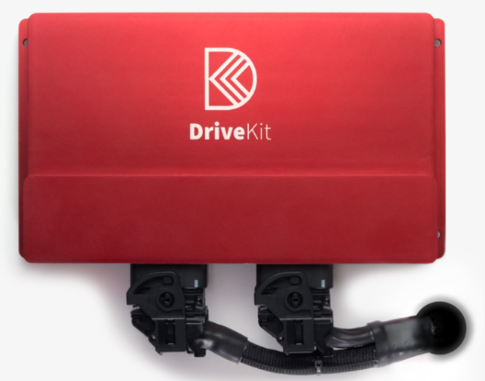

Contact
Stephen Kraemer
phone: +1 (248) 724-2883
E-mail: Kraemer@fev.com

